Part 1
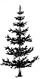
- (physics only)

Y
X
F
F
2F
2F

  - Draw the symbol for a convex lens at the point labelled X. (1)

  - What is the correct name for line Y? (1)
  - What is the correct name for the distance from point X to point F? (1)
  - One ray has been partly drawn. Complete the path of this ray. Put an arrow on this ray (1)
  - Draw a second ray on the diagram to show how the image position can be found. (1)
  - Describe the image produced by this lens. (2)

- Below are two types of lens. Name each type of lens and complete the three light rays passing through each lens. (physics only) (4)

Type of lens Type of lens

- A convex lens produces an image 35mm tall when a 5mm tall object is viewed. Calculate the magnification produced by this lens. (physics only) (2)

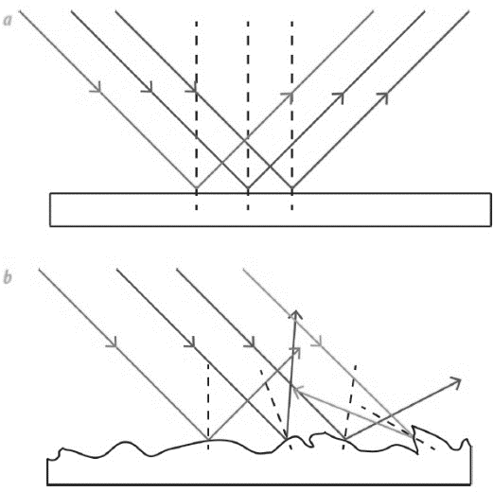
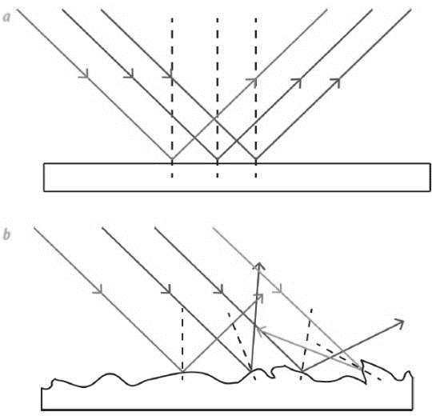
- The diagrams show light rays being reflected off two types of surface. (physics only)

B
A

  - What type of reflection is shown at A and at B? (2)

  - Which surface is likely to be a smooth piece of white paper? (1)

- White light is shining on a green leaf and on a bottle of red juice.

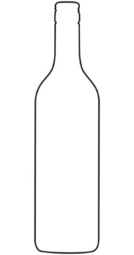
White light
Green light
White light

Red light

Describe what is happening to the spectrum colours of light in each diagram. (physics only) (4)

If a blue object in a dark room is illuminated with a red light, what colour will the object appear?
(physics only) (1)

Part 2
- All electromagnetic waves have features in common. The table below lists features of waves. Tick the correct boxes that apply to all electromagnetic waves. (3)
Property | True | False
They are all transverse waves
They have different speeds
They have different frequencies
They all have the same wavelength
They can all be reflected, refracted and transmitted
They can all travel through a vacuum

- The diagram below shows the electromagnetic spectrum. Three of the waves have not been named.
 | Microwaves |  | Visible light | Ultra-violet |  | Gamma

Increasing frequency
- Fill in the three spaces above with the correct names. (3)
- Which of the waves above is used in TV remote controls? (1)
- Which of the waves above is satellite TV? (1)

- When an infrared heater is switched on, a person a few metres away begins to warm up. Explain what has moved from the heater to the person and how this occurred. (2)

- The diagram shows a wave front being refracted as it enters a block of glass from the air (HT).

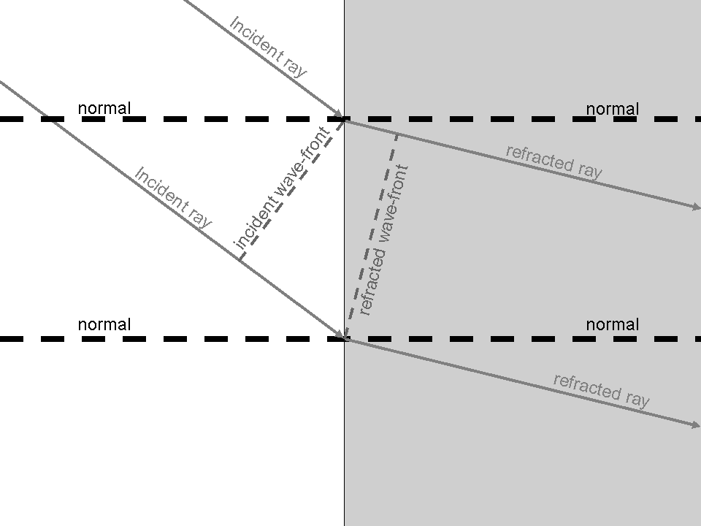

Explain in detail why the ray bends as it enters the glass. (3)

- Explain why a green object heats up more in sunlight than a white object (HT). (4)

- Television and radio broadcasts are sent through the air as radio signals.
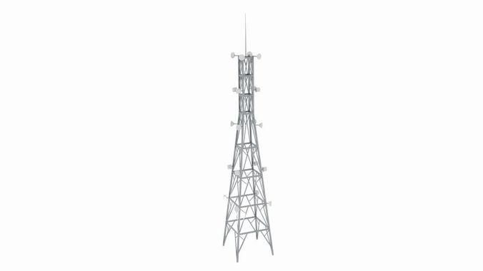
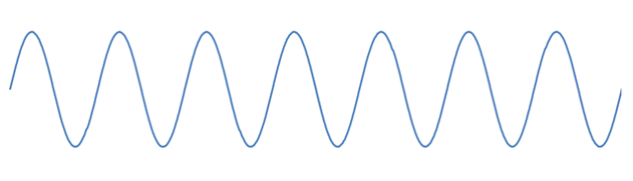
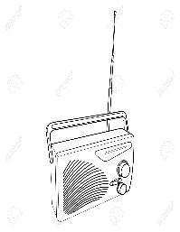

  - Why are radio waves suitable to send signals in this way? (1)

  - How is the radio signal produced in the transmitting antenna? (2)

  - What is produced in the aerial of the radio when it receives radio waves? (2)

- In which part of an atom are gamma waves produced? (1)
- The diagram shows the waves that make up the electromagnetic spectrum.

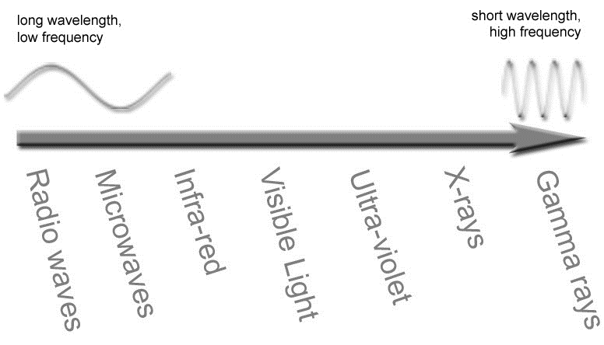

- Circle the waves that are ionising radiations. (3)
- What property of the spectrum of waves is shown to be increasing by the arrow? (1)

- What is the meaning of the term ‘radiation dose’? (1)
- Explain why ionising radiations can be dangerous if the dose becomes high. (2)
- The waves shown below represent part of the electromagnetic spectrum.
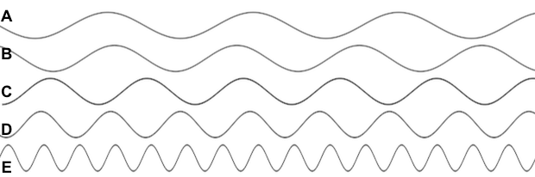

- Which wave is likely to be a radio wave? (1)
- Which wave would be carrying the greatest amount of energy? (1)
- Which wave could be used for medical imaging? (1)
- If the waves represent the colours of visible light, what colour could wave C represent? (1)

- Give the most suitable type of electromagnetic radiation for the applications stated: (5)

Application | Type of electromagnetic radiation
Satellite communications, cooking food
Fluorescent lamps, disinfecting water, security marking
Cooking, thermal imaging, short range communications
Sterilising food and medical equipment, cancer treatment
Vision, photography, illumination

Property | True | False
A black body absorbs all radiation that falls on it
A black body always reflects radiation at a longer wavelength than that which it receives
A black body is an excellent emitter of radiation
A black body transmits all the radiation that falls on it
- The table describes some properties of a perfect black body. Put a tick in the correct box to show whether the statement is true or false. (4)

- A piece of iron is heated in a furnace until it is white hot.
How will the radiation emitted from the hot metal, differ from the radiation emitted when the metal was cold? (2)
- The black cube below is in a warm room. Its temperature is constant.
What is the relationship between radiated and absorbed radiation for this object? (2)
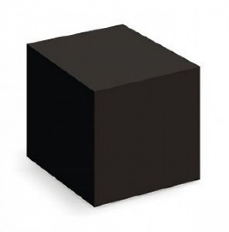

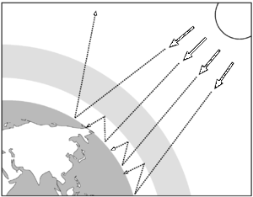
- The diagram shows how the Earth absorbs and emits radiation.

Use the diagram to help explain how changes between absorbed and emitted radiation could affect the temperature of the Earth. (4)

